**MEDMEER WEBSITE**



A

Human Computer Interface Course Project Report

in partial fulfilment of the degree

**Bachelor of Technology**

in

**Computer Science & Engineering**

**By**

M. HANISHKA 2303A51684

P. SHIVANI 2303A510I4

Under the guidance of

FAIZA IRAM  
Assistant Professor

**Submitted to**

**School of Computer Science and** **Artificial Intelligence**



1



**DEPARTMENT OF COMPUTER SCIENCE & ENGINEERING**

**CERTIFICATE**

This is to certify that the **Human Computer Interface** Report entitled **“MEDMEER”** is a record of bonafide work carried out by the student M. HANISHKA, P. SHIVANI bearing Roll No(s) 2303A51684, 2303A510I4 during the academic year 2024-25 in partial fulfillment of the award of the degree of ***Bachelor of Technology*** in **Computer Science & Artificial Intelligence** by the SR University, Ananthasagar, Hanamakonda.

**Lab In-charge Head of the Department**

FAIZA IRAM DR. M. Sheshikala  
Asst.Professor Dept of CSE, Assoc. Prof. & HOD(CSE).

SR Engineering College, SR Engineering College,

Ananthasagar, Warangal. Ananthasagar, Warangal

**2**

**ACKNOWLEDGEMENT**

We owe an enormous debt of gratitude to our project guide **Faiza Iram**, Assistant Professor as well as Head of the CSE Department **Dr. M. Sheshikala**, Associate Professor for guiding us from the beginning through the end of the Project with their intellectual advices and insightful suggestions. We truly value their consistent feedback on our progress, which was always constructive and encoraging and ultimately drove us to the right direction. We wish to take this opportunity to express our sincere gratitude and deep sense of respect to our beloved Vice Chancellor, **Prof. Deepak Garg**, for his continuous support and guidance to complete this project in the institute. Finally, we express our thanks to all the teaching and non-teaching staff of the department for their suggestions and timely support.

**3**

**TABLE OF CONTENT**

|  |  |
| --- | --- |
| **TOPIC** | **PAGE NO** |
| Abstract | 5 |
| Objective | 6 |
| Existing System | 7 |
| Proposed System | 8 - 9 |
| Software and Hardware requirements | 10 - 11 |
| Elements used in the project | 12 - 13 |
| Implementation | 14 - 22 |
| Design | 23 - 26 |
| Conclusion | 27 |

**4**

**ABSTRACT**

The **MedMeer Website** is an innovative and user-centric web application designed torevolutionize healthcare accessibility and personalized medical assistance. This platform offers a seamless interface for patients to connect with healthcare services, providing functionalities such as account registration, login, and a robust system for submitting and managing patient details. The primary goal is to suggest medicines, dosages, and diet plans tailored to individual health profiles, enabling efficient management of chronic and acute health conditions. The website consists of multiple modules, including a **Home Page** with intuitive navigation, a **Login/Register System** for secure access, and detailed forms for submitting health information. Additional features include a **Feedback Mechanism** for user inputs and a **Contact Us Page** to ensure effective communication between users and medical authorities. A responsive toggle menu enhances usability, while interactive design elements like sliders and rating systems enrich the user experience. The MedMeer platform is developed with HTML, CSS, and JavaScript, focusing on simplicity, accessibility, and security. It also incorporates Aadhaar-based verification and centralized control by medical authorities, ensuring the reliability of suggested solutions. By bridging the gap between technology and healthcare, MedMeer aims to empower users with actionable insights for better health management and a higher quality of life.  
  
  
  
  
  
  
  
  
 5  
  **OBJECTIVE**

The objective of the **MedMeer Website** is to create a comprehensive and user-friendly platform that enhances healthcare accessibility and personalization. It aims to simplify healthcare access by connecting users with reliable medical resources and solutions through an intuitive interface. The website focuses on delivering personalized recommendations, including tailored medicine suggestions, dosages, and diet plans, based on individual health profiles and conditions. It ensures secure and reliable usage by implementing robust login and registration systems, including Aadhaar-based verification, to maintain user data integrity and trust. Additionally, MedMeer facilitates effective communication through features like feedback collection and contact forms, enabling active interaction between users and medical authorities. By incorporating interactive elements such as toggled menus, sliders, and accessible navigation, the platform provides an engaging and seamless user experience. MedMeer ultimately bridges the gap between technology and healthcare, empowering users to manage their health effectively and conveniently.

6

**EXISTING SYSTEM:**

The existing system of the MedMeer Website typically includes the following components and features:

1. **Website Interface:** A basic user interface displaying limited healthcare services and features, without interactive or personalized user experiences.
2. **User Registration and Login:** Users can create accounts, log in, and manage their profiles with basic details like email, contact information, and passwords.
3. **Patient Details Submission:** Users can fill out forms to submit basic health details, but the system lacks advanced data analysis or tailored recommendations.
4. **Appointment Booking:** Patients can schedule appointments with doctors, but without real-time availability or automated reminders.
5. **Medicine and Diet Suggestions:** The website offers generalized suggestions for health issues, but these are not personalized to individual patient needs or conditions.
6. **Feedback Mechanism:** Users can provide feedback or ratings, but the system may lack an intelligent way to analyze and act upon user responses.
7. **Contact and Support:** A contact page exists for users to send inquiries, but response times and automated support functionalities are limited.
8. **Basic Navigation:** Navigation is straightforward but lacks advanced features like interactive sidebars, draggable sliders, or enhanced menu options for a seamless user experience.
9. **Minimal Integration with Central Agencies:** The platform has limited or no integration with central medical authorities for authentication and monitoring of health services.
10. **Social Media Integration:** Basic social media links are provided, but there is no dynamic engagement or interaction through these platforms.

7

**PROPOSED SYSTEM:**

The proposed system for the *MedMeer Website* includes the following components and features:

1. **Enhanced Patient Data Management:** The platform will allow users to submit detailed health profiles, including medical history, ongoing conditions, and lifestyle preferences, enabling personalized health recommendations.
2. **Tailored Medicine and Diet Suggestions:** An intelligent recommendation system will suggest medicines, dosages, diet plans, and steps for managing chronic conditions based on individual health details.
3. **Interactive User Interface:** The website will feature an engaging, responsive design with an intuitive navigation menu, image sliders, and accessible links to critical pages like login, profile, and health suggestions.
4. **Appointment Booking System:** Real-time appointment scheduling with automated reminders and notifications to improve user convenience and minimize missed consultations.
5. **Feedback and Rating System:** Patients can rate the platform and provide feedback to improve services. A 5-star rating system will be integrated into the feedback page for user convenience.
6. **Secure Login/Registration System:** The system will include separate login and registration forms with robust validation for details like Aadhaar number, contact number, and secure password storage to ensure user privacy and security.
7. **Integration with Medical Authorities:** Centralized control by medical agencies to monitor and verify the authenticity of health recommendations and ensure adherence to regulations.
8. **Comprehensive Contact and Support Page:** A streamlined process for submitting inquiries and booking appointments, supplemented with multiple channels like live chat and FAQs for immediate assistance.
9. **Personalized Health Monitoring:** The system will offer features like saving user health progress and maintaining medical records for future consultations and decision-making.

8

1. **Prominent Social Media Engagement:** The platform will actively engage with users through integrated social media handles, newsletters, and updates on medical advancements or tips for healthier living.
2. **Responsive and Accessible Design:** The system will be optimized for desktops, tablets, and mobile devices, ensuring fast load times and a seamless experience for all users.

9

**SOFTWARE REQUIREMENTS:**

**TECHNICAL REQUIREMENTS:**  
➢ **HTML (HyperText Markup Language):** Used to create the structure and content of the MedMeer website.  
➢ **CSS (Cascading Style Sheets):** Used to style the website, ensuring a visually appealing and responsive design across all devices.  
➢ **JavaScript:** Used for interactivity, including dynamic navigation menus, form validation, image sliders, and other user interface features.

**HARDWARE REQUIREMENTS:**

1. **Web Browser:**
   * **Purpose:** Required for testing the MedMeer website across multiple browsers to ensure compatibility.
   * **Specifications:** Latest versions of Chrome, Firefox, Safari, and Edge for debugging and verifying consistent functionality.
2. **Code Editor/IDE:**
   * **Examples:** Visual Studio Code, Sublime Text, or Atom.
   * **Purpose:** Used for writing and managing the website's front-end code. These editors provide features like syntax highlighting, debugging tools, and integration with version control systems like Git.
3. **Graphics Software (Optional for Asset Creation):**
   * **Examples:** Adobe Photoshop, Figma, or Canva.
   * **Purpose:** To design and edit visual assets such as the MedMeer logo, navigation icons, and slider images. This enhances the user interface and branding.

10

1. **Testing Devices:**
   * **Purpose:** Required to test the MedMeer website’s responsiveness and functionality across various devices and screen sizes.
   * **Specifications:** Smartphones, table ts, and desktops with diverse screen resolutions.

**11**

**ELEMENTS USED IN THE PROJECT:**

➢ **User Interface (UI):**  
The user interface provides intuitive front-end components for seamless interaction. It includes navigation menus, forms for login/register, sliders for images, and banners for visual appeal. Features such as health details submission, medicine suggestions, and responsive feedback mechanisms enhance the overall user experience.

➢ **Database:**  
A database stores critical information, such as patient profiles, health conditions, suggested medicines, dosage instructions, and appointment bookings. It ensures efficient data storage, retrieval, and management for the website’s operations.

➢ **Health Profile System:**  
This module allows users to create and update profiles, including fields for personal and medical details. It facilitates tailored medicine suggestions and chronic care plans based on the user’s input.

➢ **Medicine Suggestion System:**  
The core of the project, this system recommends appropriate medicines, dosages, and diet plans based on the user's health conditions. It includes an easy-to-read summary and step-by-step care instructions for chronic illnesses.

➢ **Mobile and Online Responsiveness:**  
The site is fully responsive, offering a consistent and optimized browsing experience across all devices, including mobile phones, tablets, and desktops.

12

➢ **Security:**  
Robust security measures include user authentication, Aadhaar verification, and encrypted data handling for sensitive information such as health details and login credentials.

➢ **Integration:**  
Integration with third-party services like payment gateways (e.g., Razorpay or Paytm) for appointment booking and APIs for medicine databases ensures an enriched and interconnected user experience.

13

**IMPLEMENTATION:**

**CODE:**

**//Home page html code :**<!DOCTYPE html>

<html lang="en">

<head>

    <meta charset="UTF-8">

    <meta name="viewport" content="width=device-width, initial-scale=1.0">

    <title>MedMeer - Home</title>

    <link rel="stylesheet" href="projectstyles.css">

    <link href="https://fonts.googleapis.com/css2?family=Poppins:wght@300;400;500;700&family=Belleza&display=swap" rel="stylesheet">

    <link rel="stylesheet" href="https://cdnjs.cloudflare.com/ajax/libs/font-awesome/6.0.0-beta3/css/all.min.css">

    <style>

        /* Basic Styles */

        body {

            background-color: #ffe6e6;

            font-family: 'Poppins', sans-serif;

            color: #333;

            margin: 0;

        }

        /* Header */

        header {

            display: flex;

            align-items: center;

            padding: 10px 20px;

            background-color: #ffcccc;

            color: #333;

        }

        .menu-btn {

            font-size: 1.5rem;

            background: none;

            border: none;

            cursor: pointer;

            color: #333;

        }

        .site-title {

            font-family: 'Belleza', sans-serif;

            font-size: 2rem;

            color: #333;

            margin-left: 15px;

            flex-grow: 1;

14

        }

        .logo {

            height: 50px;

/* Sidebar */

        .sidebar {

            display: none;

            position: fixed;

            left: 0;

            top: 0;

            width: 200px;

            height: 100%;

            background: #ffb3b3;

            padding-top: 60px;

            box-shadow: 2px 0px 5px rgba(0, 0, 0, 0.2);

        }

        .sidebar ul {

            list-style-type: none;

            padding: 0;

        }

        .sidebar ul li a {

            display: block;

            padding: 15px;

            color: #333;

            text-decoration: none;

        }

        /* Scrolling Message */

        .scrolling-message {

            background-color: #ff9999;

            padding: 10px;

            color: #fff;

            font-size: 1.2rem;

            overflow: hidden;

            white-space: nowrap;

        }

        .image-slider {

            display: flex;

            align-items: center;

            justify-content: center;

            background-color: #ffc1c1;

            padding: 20px;

            15

        }

        .slider-container {

            display: flex;

            overflow: hidden;

            width: 80%;

        }

        .slider-img {

            width: 100%;

            border-radius: 8px;

            transition: transform 1s ease;

        }

        .dots {

            position: absolute;

            bottom: 10px;

            text-align: center;

            width: 100%;

        }

        .dot {

            cursor: pointer;

            height: 15px;

            width: 15px;

            margin: 0 3px;

            background-color: #bbb;

            border-radius: 50%;

            display: inline-block;

        }

        .dot.active {

            background-color: #e60000;

        }

        /* JavaScript to Auto Slide Images */

    </style>

</head>

<!-- Header -->

    <header>

        <button class="menu-btn" onclick="toggleMenu()">☰</button>

        <h1 class="site-title">MedMeeR</h1>

        <img src="C:\Users\hanis\OneDrive\Desktop\HCI LAB\medmeerlogo.project.png" alt="MedMeer Logo" class="logo">

    </header>

    <!-- Sidebar -->

    <nav class="sidebar" id="sidebar">

        16

            <li><a href="project.html">Home</a></li>

            <li><a href="medmeer.html">The MedMeer</a></li>

            <li><a href="login.html">Login</a></li>

            <li><a href="register.html">Register</a></li>

            <li><a href="submit_details.html">Problem Picture</a></li>

            <li><a href="contact.html">Contact Us</a></li>

            <li><a href="feedback.html">Feedback</a></li>

        </ul>

    </nav>

    <!-- Scrolling Message -->

    <div class="scrolling-message" id="scrolling-message">

        <marquee behavior="scroll" direction="left">

            Welcome to MedMeer! | New updates available | Personalized health suggestions for chronic issues now live | Join us to improve your health journey!

        </marquee>

    </div>

    <!-- Main Content -->

    <main>

        <section class="image-slider">

            <div class="slider-container" id="slider-container">

                <img src="C:\Users\hanis\OneDrive\Desktop\HCI LAB\img2.jpg" alt="MedMeer Society" class="slider-img">

                <img src="C:\Users\hanis\OneDrive\Desktop\HCI LAB\img3.png" alt="MedMeer Services" class="slider-img">

                <img src="C:\Users\hanis\OneDrive\Desktop\HCI LAB\img5.jpg" alt="MedMeer Community" class="slider-img">

            </div>

            <div class="dots">

                <span class="dot" onclick="moveToSlide(0)"></span>

                <span class="dot" onclick="moveToSlide(1)"></span>

                <span class="dot" onclick="moveToSlide(2)"></span>

            </div>

        </section>

        <!-- Welcome Note Section -->

        <section class="welcome-note">

            <h2>Welcome to MedMeeR</h2>

            <p>We are dedicated to providing the best healthcare solutions tailored to your needs.</p>

        </section>

    </main>

    <!-- Footer -->

    <footer>

        <div class="social-media">

            <a href="#"><i class="fab fa-facebook"></i></a>

            <a href="#"><i class="fab fa-instagram"></i></a>

            <a href="#"><i class="fab fa-twitter"></i></a>

            <a href="#"><i class="fab fa-youtube"></i></a>

            <a href="#"><i class="fab fa-whatsapp"></i></a>

        </div>

        <p>&copy; 2024 Indian Medical Authorities. All rights reserved.</p>

17

    <!-- JavaScript -->

    <script>

        // Toggle Sidebar Menu

        function toggleMenu() {

            const sidebar = document.getElementById('sidebar');

            sidebar.style.display = sidebar.style.display === 'block' ? 'none' : 'block';

        }

        // Image Slider Auto-scroll

        let currentSlide = 0;

        const slides = document.getElementsByClassName('slider-img');

        const dots = document.getElementsByClassName('dot');

        function showSlide(index) {

            for (let i = 0; i < slides.length; i++) {

                slides[i].style.display = 'none';

                dots[i].classList.remove('active');

            }

            slides[index].style.display = 'block';

            dots[index].classList.add('active');

        }

        function nextSlide() {

            currentSlide = (currentSlide + 1) % slides.length;

            showSlide(currentSlide);

        }

        setInterval(nextSlide, 3000); // Change image every 3 seconds

    </script>

</body>

</html>

<!DOCTYPE html>

<html lang="en">

<head>

    <meta charset="UTF-8">

    <meta name="viewport" content="width=device-width, initial-scale=1.0">

    <title>MedMeer - About Us</title>

    <link href="https://fonts.googleapis.com/css2?family=Poppins:wght@300;400;500;700&family=Courgette&display=swap" rel="stylesheet">

    <link rel="stylesheet" href="styles.css">

    <style>

        body {

            background-color: #ffe6e6; /* Pale red background */

            font-family: 'Poppins', sans-serif;

            margin: 0;

            padding: 0;

        }

18

        /* Header and Logo */

        header {

            display: flex;

            align-items: center;

            background-color: #ffcccc;

            padding: 1rem;

            color: #333;

            position: relative;

            box-shadow: 0 2px 5px rgba(0, 0, 0, 0.1);

        }

        .menu-btn {

            font-size: 1.5rem;

            background: none;

            border: none;

            cursor: pointer;

            color: #333;

            margin-right: 1rem;

        }

        .site-title {

            font-family: 'Courgette', cursive;

            font-size: 2.5rem;

            color: black;

            flex-grow: 1;

            text-align: center;

        }

        .logo {

            height: 50px;

            margin-left: auto;

        }

        /* Sidebar Navigation */

        .sidebar {

            width: 200px;

            background-color: #ff9999;

            height: 100vh;

            position: fixed;

            top: 0;

            left: -200px; /* Initially hidden */

            transition: 0.3s ease;

            padding-top: 60px;

        }

        .sidebar ul {

19

            padding: 0;

        }

        .sidebar ul li {

            padding: 15px;

            text-align: center;

        }

        .sidebar ul li a {

            text-decoration: none;

            color: white;

            font-weight: bold;

            display: block;

        }

        /* Main Content */

        main {

            margin-left: 0;

            padding: 2rem;

            transition: margin-left 0.3s ease;

        }

        .about-us {

            background-color: white;

            padding: 2rem;

            border-radius: 8px;

            box-shadow: 0 4px 8px rgba(0, 0, 0, 0.2);

            max-width: 800px;

            margin: auto;

            font-family: 'Poppins', sans-serif;

            color: #333;

        }

        h2 {

            color: #ff6666;

            font-family: 'Courgette', cursive;

            font-size: 2.2rem;

            margin-bottom: 1rem;

            text-align: center;

        }

        h3 {

            color: #cc3333;

            font-weight: 500;

            font-size: 1.8rem;

            margin-top: 1rem;

20

**//Home page css code:**\* {

    margin: 0;

    padding: 0;

    box-sizing: border-box;

}

body {

    font-family: 'Poppins', sans-serif;

    background: url('background.jpg') no-repeat center center fixed;

    background-size: cover;

    color: #333;

}

/* Header */

header {

    display: flex;

    justify-content: center;

    align-items: center;

    position: relative;

    padding: 20px 0;

    background-color: rgba(255, 255, 255, 0.8);

}

.site-title {

    font-family: 'Belleza', cursive;

    font-size: 4rem;

    color: black;

    text-align: center;

}

.logo {

    position: absolute;

    right: 20px;

    height: 120px;  /* Adjusted logo size to medium-big */

}

.menu-btn {

    position: absolute;

    left: 20px;

    font-size: 24px;

    background: none;

    border: none;

    cursor: pointer;

}

.

21

    background-color: rgba(0, 0, 0, 0.9);

    color: white;

    position: fixed;

    height: 100%;

    top: 0;

    left: -250px;

    overflow-y: auto;

    transition: 0.3s;

}

.sidebar ul {

    list-style-type: none;

    padding-top: 20px;

}

.sidebar ul li {

    padding: 20px;

    border-bottom: 1px solid #444;

}

.sidebar ul li a {

    color: white;

    text-decoration: none;

    font-size: 18px;

}

**//Home page javascript code:**

/ Toggle Sidebar Menu

function toggleMenu() {

    const sidebar = document.getElementById('sidebar');

    sidebar.classList.toggle('show');

}

// Draggable Image Slider with Dots

let currentSlide = 0;

const slides = document.getElementsByClassName('slider-img');

const dots = document.getElementsByClassName('dot');

function moveToSlide(slideIndex) {

    currentSlide = slideIndex;

    const sliderContainer = document.getElementById('slider-container');

    sliderContainer.style.transform = `translateX(-${slideIndex * 100}%)`;

    updateDots();

}

function updateDots() {

    for (let i = 0; i < dots.length; i++) {

        dots[i].classList.remove('active-dot');

    }

22

**Design:  
  
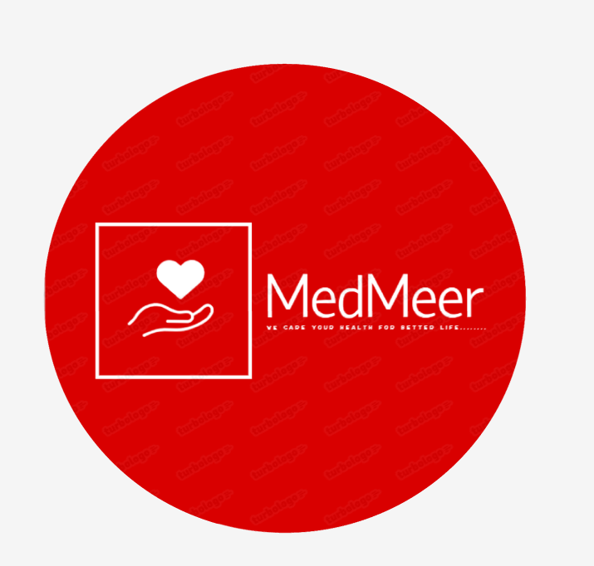**

**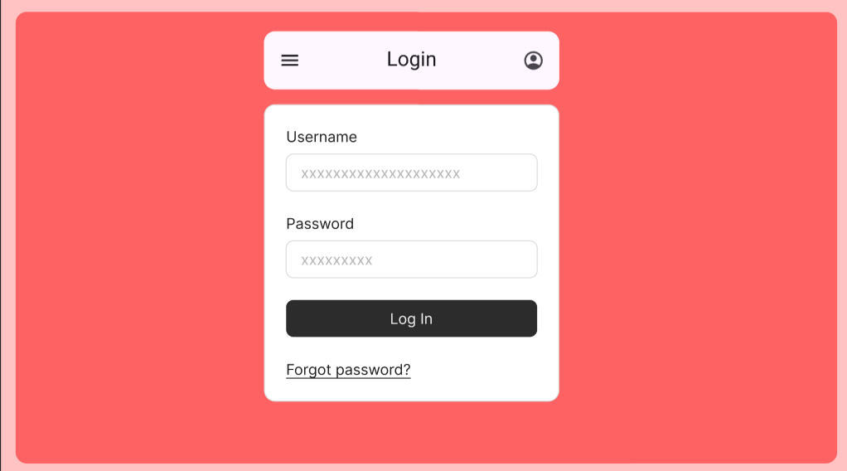  
  
  
 23**

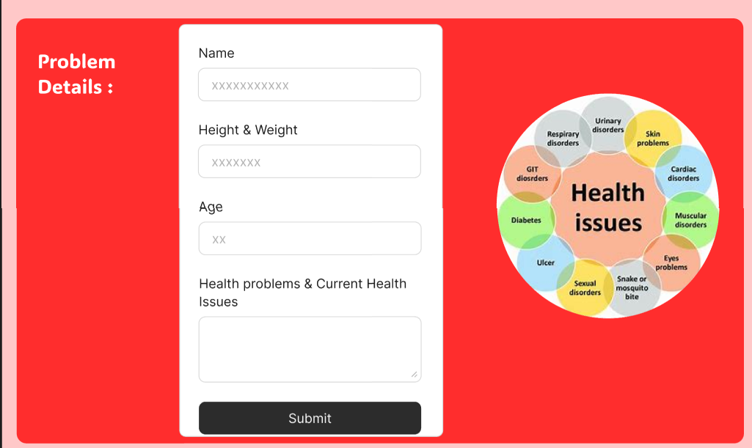

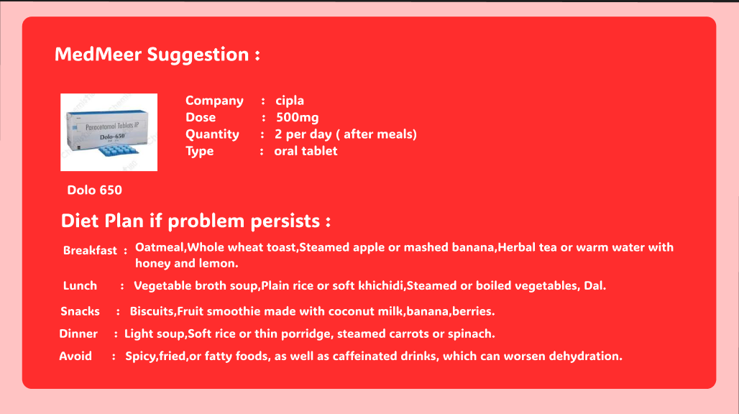

24

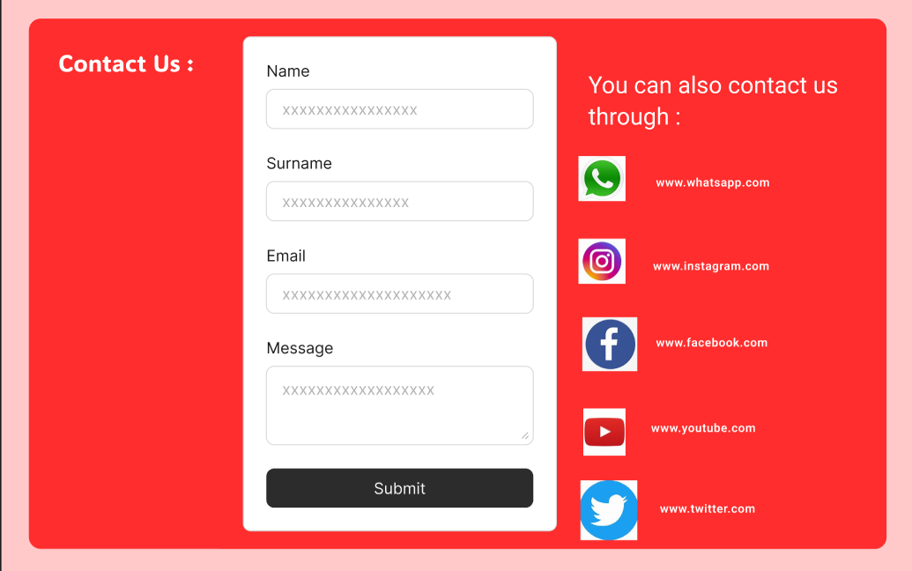

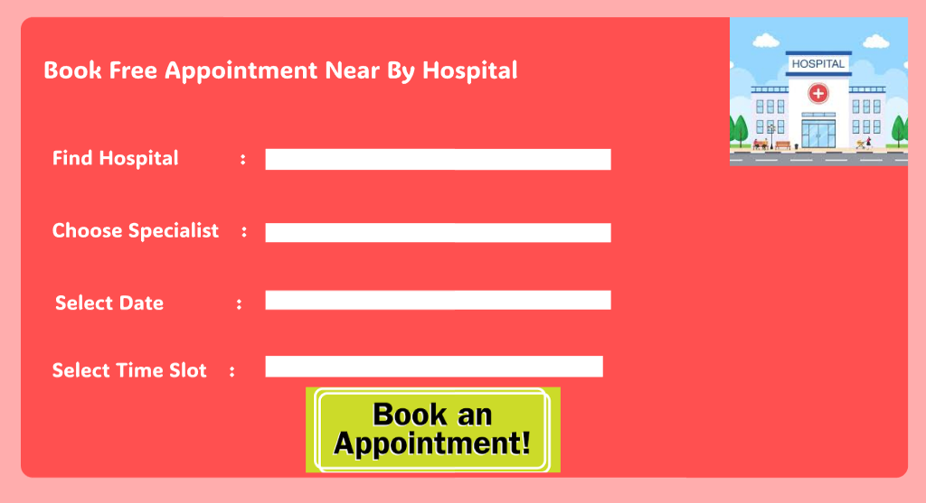

25

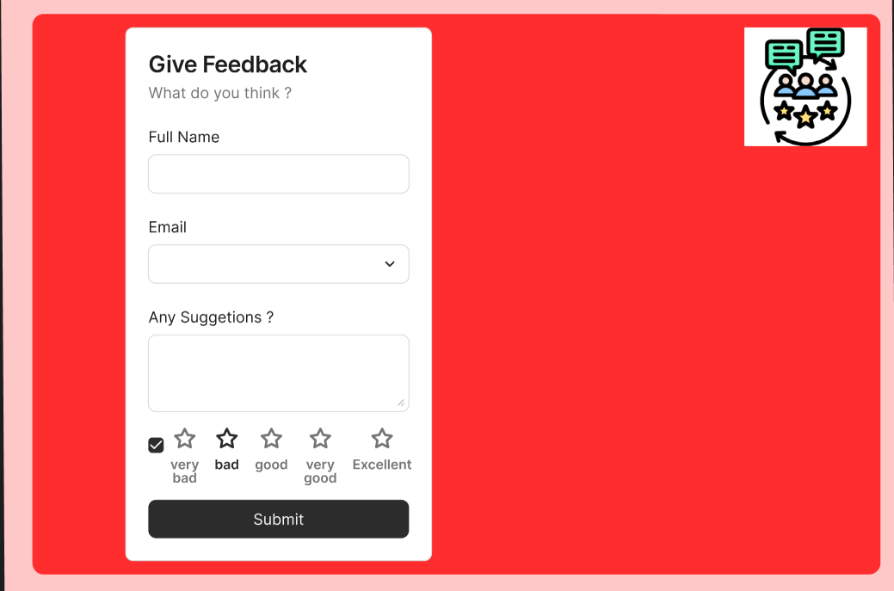

26

**CONCLUSION:**

The development of the MedMeer website significantly enhances the user experience and operational efficiency in providing personalized medical guidance and chronic care solutions. A well-structured and responsive platform ensures that users can seamlessly input health details, receive tailored medicine recommendations, and access diet plans, irrespective of the device they use.

By integrating features such as secure user authentication, Aadhaar-based verification, and encrypted handling of sensitive health data, the website builds trust and reliability among users. Its mobile-friendly design guarantees accessibility, allowing users to conveniently access suggestions and care plans on the go.

The inclusion of dynamic elements such as live chat support, step-by-step care instructions, and integration with third-party tools like payment gateways ensures a comprehensive and satisfying user experience. The responsive interface, combined with fast load times and intuitive navigation, facilitates ease of use for both patients and healthcare providers.

Through features like personalized care, appointment booking, and chronic problem management, the MedMeer website fosters long-term engagement, trust, and user satisfaction. Ultimately, the project contributes to improving the accessibility and quality of healthcare services, establishing a strong digital presence and catering to the growing need for efficient health management solutions in today's digital era.

27